LA IGLESIA DE JESUCRISTO DE LOS SANTOS DE LOS ÚLTIMOS DÍAS
Misión Chile Santiago Sur, Francisco Aranda 530, San Bernardo, Santiago Chile, 8070868

August 2, 2016

Kerry Scott
5308 S. Lexington
Springfield, Missouri 65810
USA

Dear Sister Scott:

We are happy to send the exciting news that after weeks of preparation in the Mexico MTC, Elder Scott has arrived safely with his group of fellow missionaries to the Chile Santiago South Mission. He was transported from the MTC to the Mission Office where he met his trainer, participated in a New Missionary Orientation and was transported to his first assigned area.

Your son has been assigned as a junior companion to Elder Gularte, from Montevideo, Uruguay. Elder Gularte is an exceptional missionary selected by President Gwilliam to guide Elder Scott through this important training period of his mission. They are assigned to labor in the Las Americas 1 sector in the La Cisterna zone.

You can expect to hear from Elder Scott by email Wednesday which is preparation day. We trust that you will also write to Elder Scott on a weekly basis. Your positive messages of support and love will be a great source of strength and encouragement to him. We will send you our weekly newsletter as well as other occasional messages. To send a letter or a package we strongly recommend you use USPS, and the following address:

Elder Scott
Chile Santiago South Mission
Apartado Postal No. 544
San Bernardo, Chile

We thank you for all that you have done to help prepare Elder Scott to faithfully serve a full time mission. We know that your family will be blessed for his sacrifice and commitment to serve the Lord. Thank you for entrusting Elder Scott to the Lord and to us. We look forward to getting to know him well as we labor together. We want you to know that we will love and watch over him while he is in our care. Please feel free to communicate with us at any time, with any concerns that you may have.
Most sincerely,
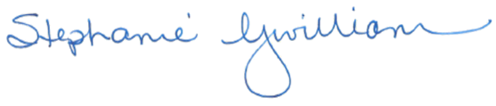
President Douglas G. Gwilliam Sister Stephanie Gwilliam

